**LAB 6 SCREENSHOTS**

1. There is a login page where user is asked to enter credentials to perform operations.

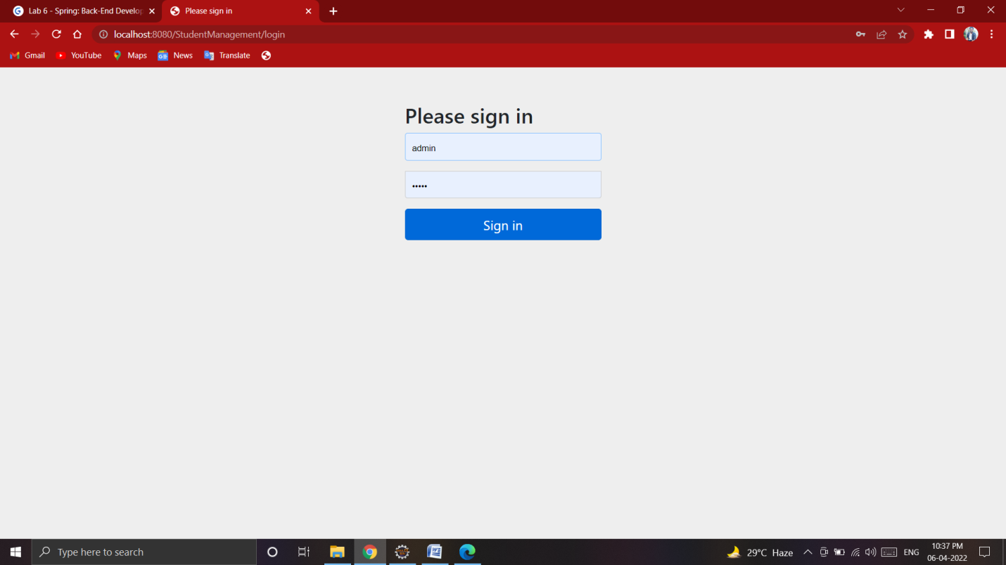

1. Insert new records into the table by clicking on Add Student.

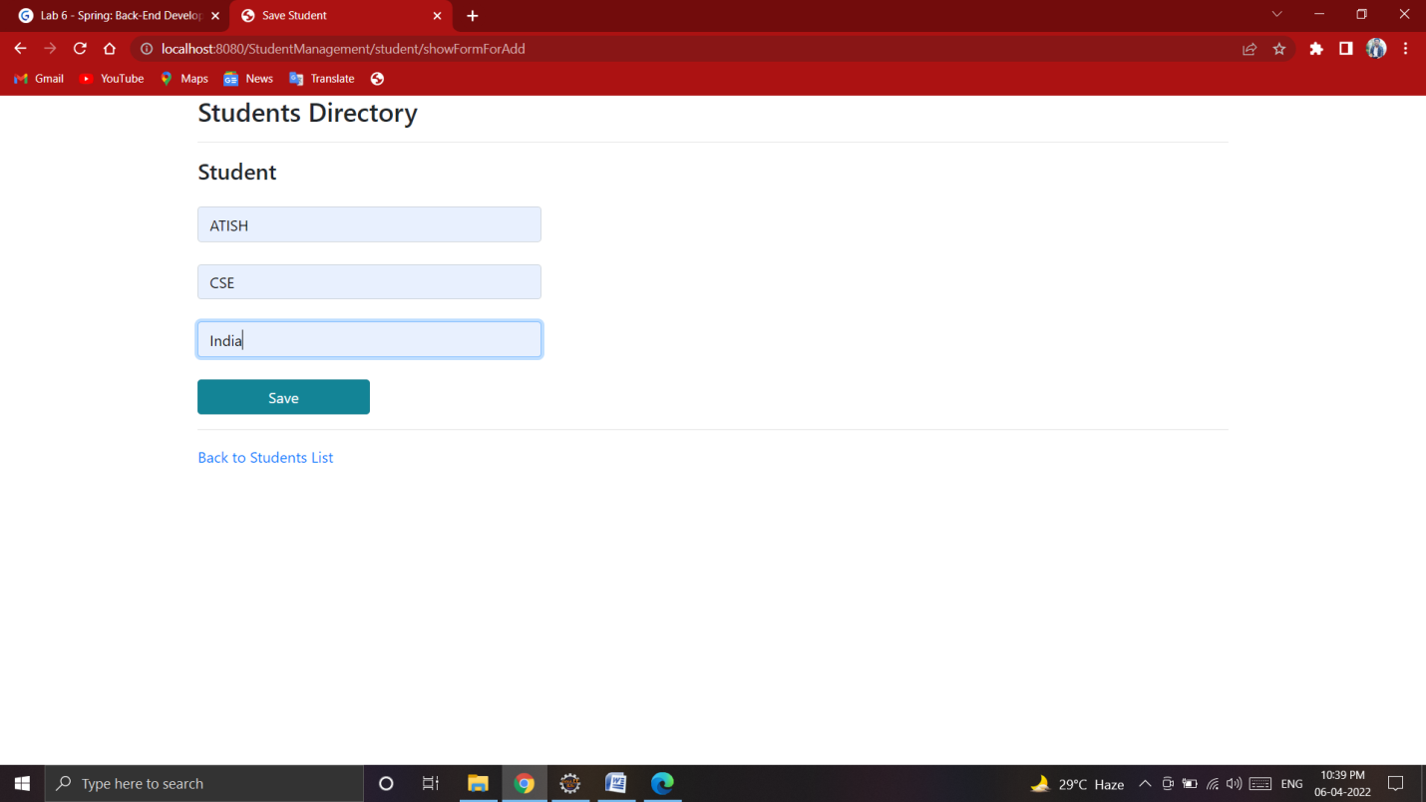

1. Update existing records into the table.

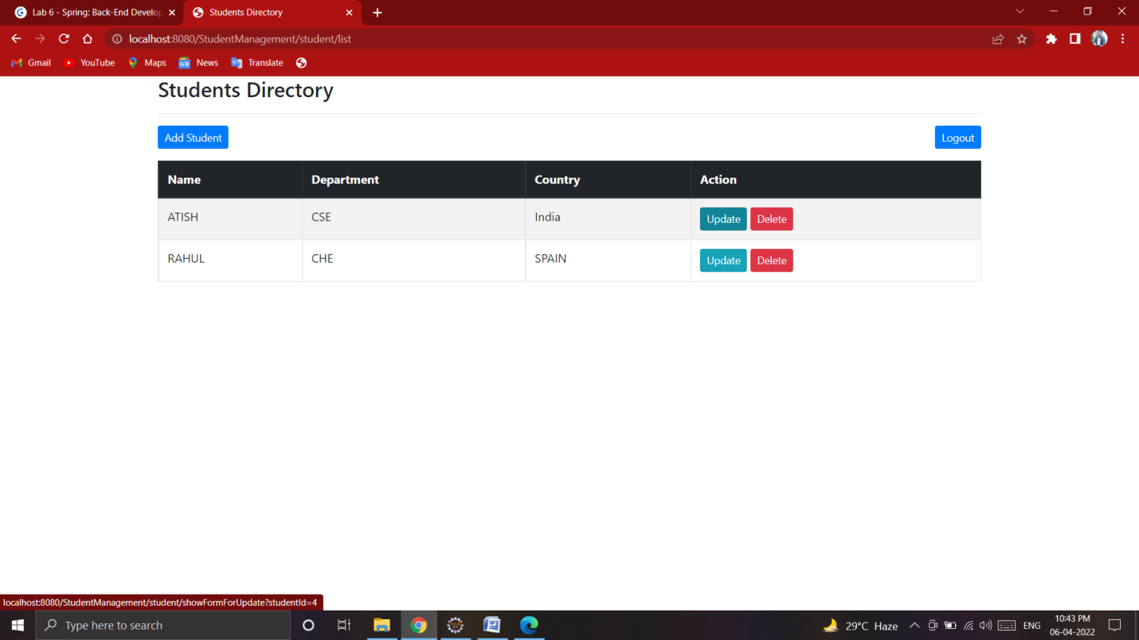

1. Added a security layer where there will be two roles USER, ADMIN.

